Common Factors – Answer Key

Date: Name:

What is a common factor?

Common factors are factors that are the same between two different numbers that are being compared.

What is a “greatest common factor?”
A greatest common factor is the largest factor that divides perfectly into two or more numbers.
Here are examples of how to use a Venn diagram to visually display the common and uncommon factors when comparing two different numbers.

Example #1- Comparing 8 and 12
The common factors of 8 and 12 are 1, 2, and 4. The greatest (largest) common factor is 4.
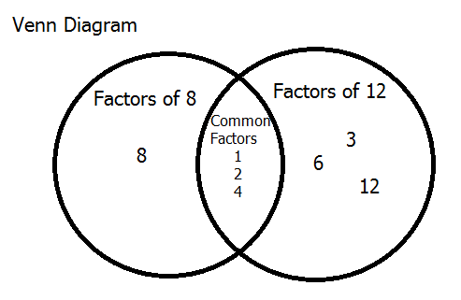
8
1 x 8
2 x 4

12
1 x 12
2 x 6
3 x 4

Example #2- Comparing 36 and 12
The common factors of 36 and 12 are 1, 2, 3, 4, 6, and 12. The greatest (largest) common factor is 12.
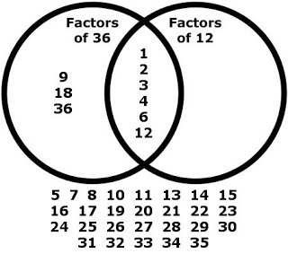
36
1 x 36
2 x 18
3 x 12
4 x 9

12
1 x 12
2 x 6
3 x 4

