Determine Common Factors and Greatest Common Factors Using a Venn diagram

Date: Name:

Instructions: Using the Venn-Diagrams below, compare numbers to determine the common factors as well as the greatest common factor. Make sure to show all of your work and the factor pairs. Write a sentence once you have solved the problem stating what the common factors are as well as what the greatest common factor is.

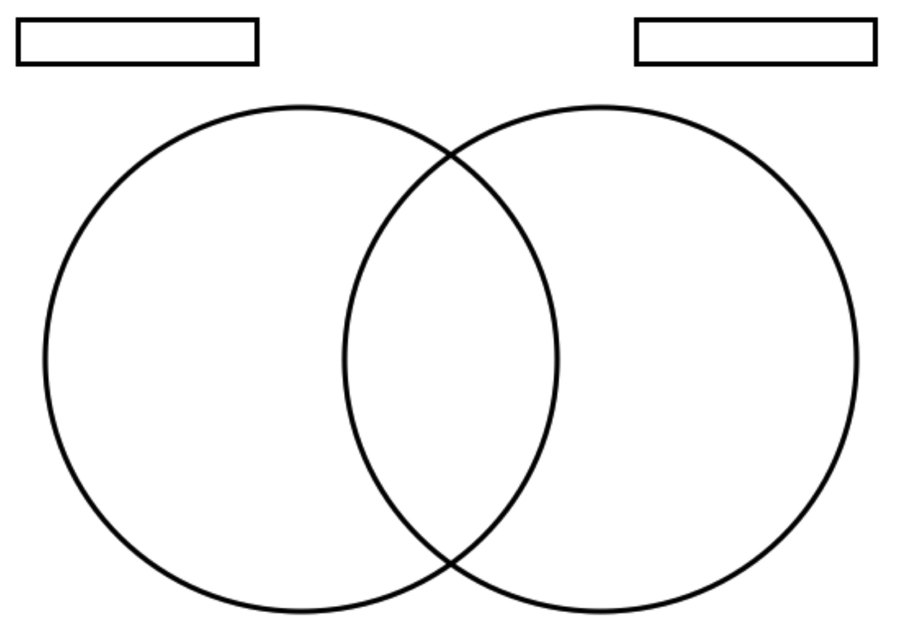
- 30 and 20

Sentence:
- 27 and 81

Sentence:
- 40 and 60

Sentence:

- 75 and 35

Sentence:

- 120 and 80

Sentence:

- 104 and 66

Sentence:

- 14 and 28

Sentence:

- 54 and 63

Sentence:

