Determine Common Factors and Greatest Common Factors Using a Venn diagram

Date: Name:

Instructions: Using the Venn-Diagrams below, compare numbers to determine the common factors as well as the greatest common factor. Make sure to show all of your work and the factor pairs. Write a sentence once you have solved the problem stating what the common factors are as well as what the greatest common factor is.

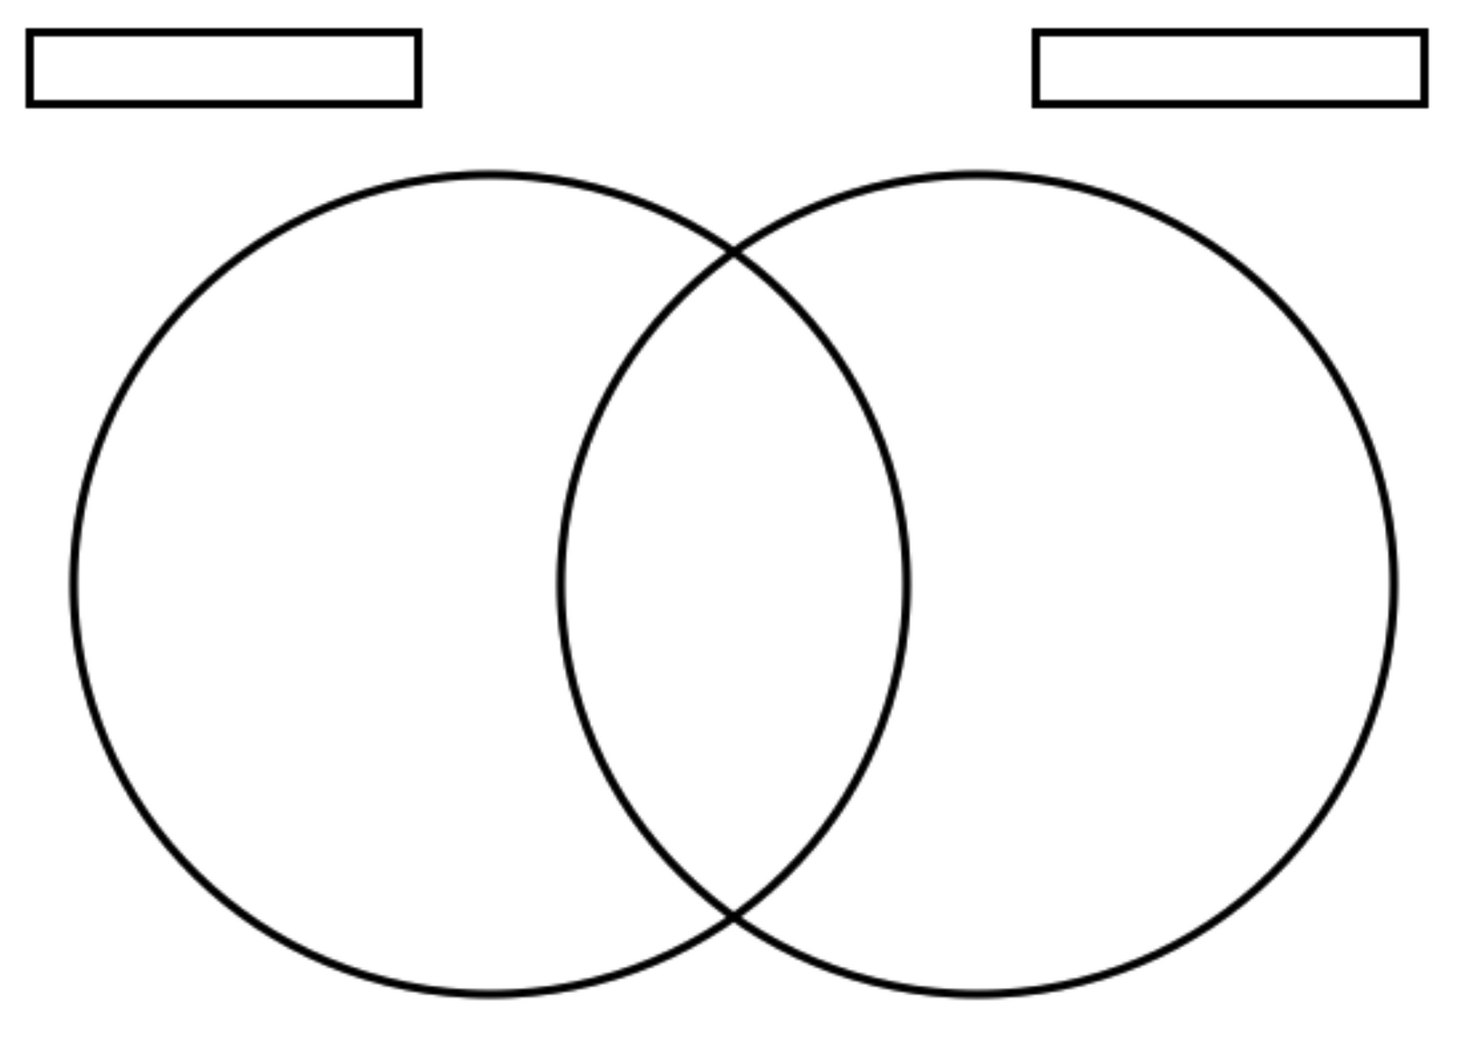
- 30 and 20

30 20

30 ÷ 1 20 ÷ 1
30 ÷ 2 20 ÷ 2
30 ÷ 3 20 ÷ 3
30÷ 4 20 ÷ 4
30 ÷ 5 20 ÷5
30 ÷ 6 20 ÷ 6
30 ÷ 7 20 ÷ 7
30 ÷ 8 20 ÷ 8
30÷ 9 20 ÷ 9

Sentence:

- 27 and 81

Sentence:

- 75 and 35

Sentence:

- 120 and 80

Sentence:

- 54 and 63

Sentence:

