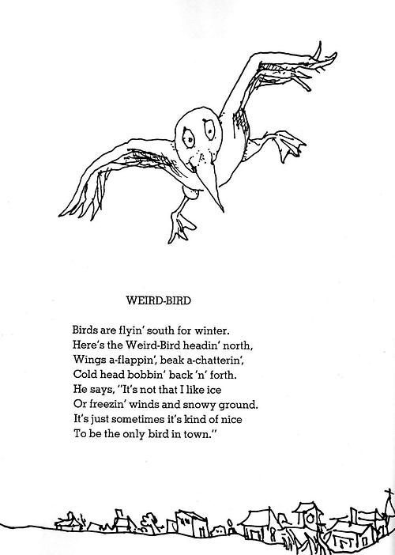
ELA Quick Write

You have 6 minutes.

Write about the poem.

Sample Questions:

- What did you like?

- What did you notice about the poem?

- How does the poem make you feel?

- Does the poem make you think of something you’ve seen or heard before? Describe.

- What do you think is the message behind this poem?

