Factor Rainbows
Date: Name:

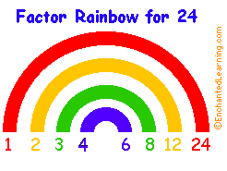
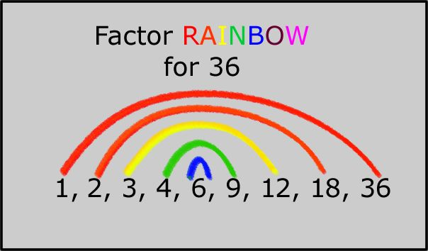
What does a Factor Rainbow look like?
Factor Rainbows are colourful visualizations to show the factor pairs that when multiplied together, equal a desired number.
On the left side is the lower number of the pair, and the arching line going to the right side leads to the larger number in the pair. You may use a calculator to help you find the factor pairs. *Your Divisibility Rules handout will help you!
Using pencil crayons, create Factor Rainbows for the following numbers:
12

20

32

72
80
65
28
30
81

