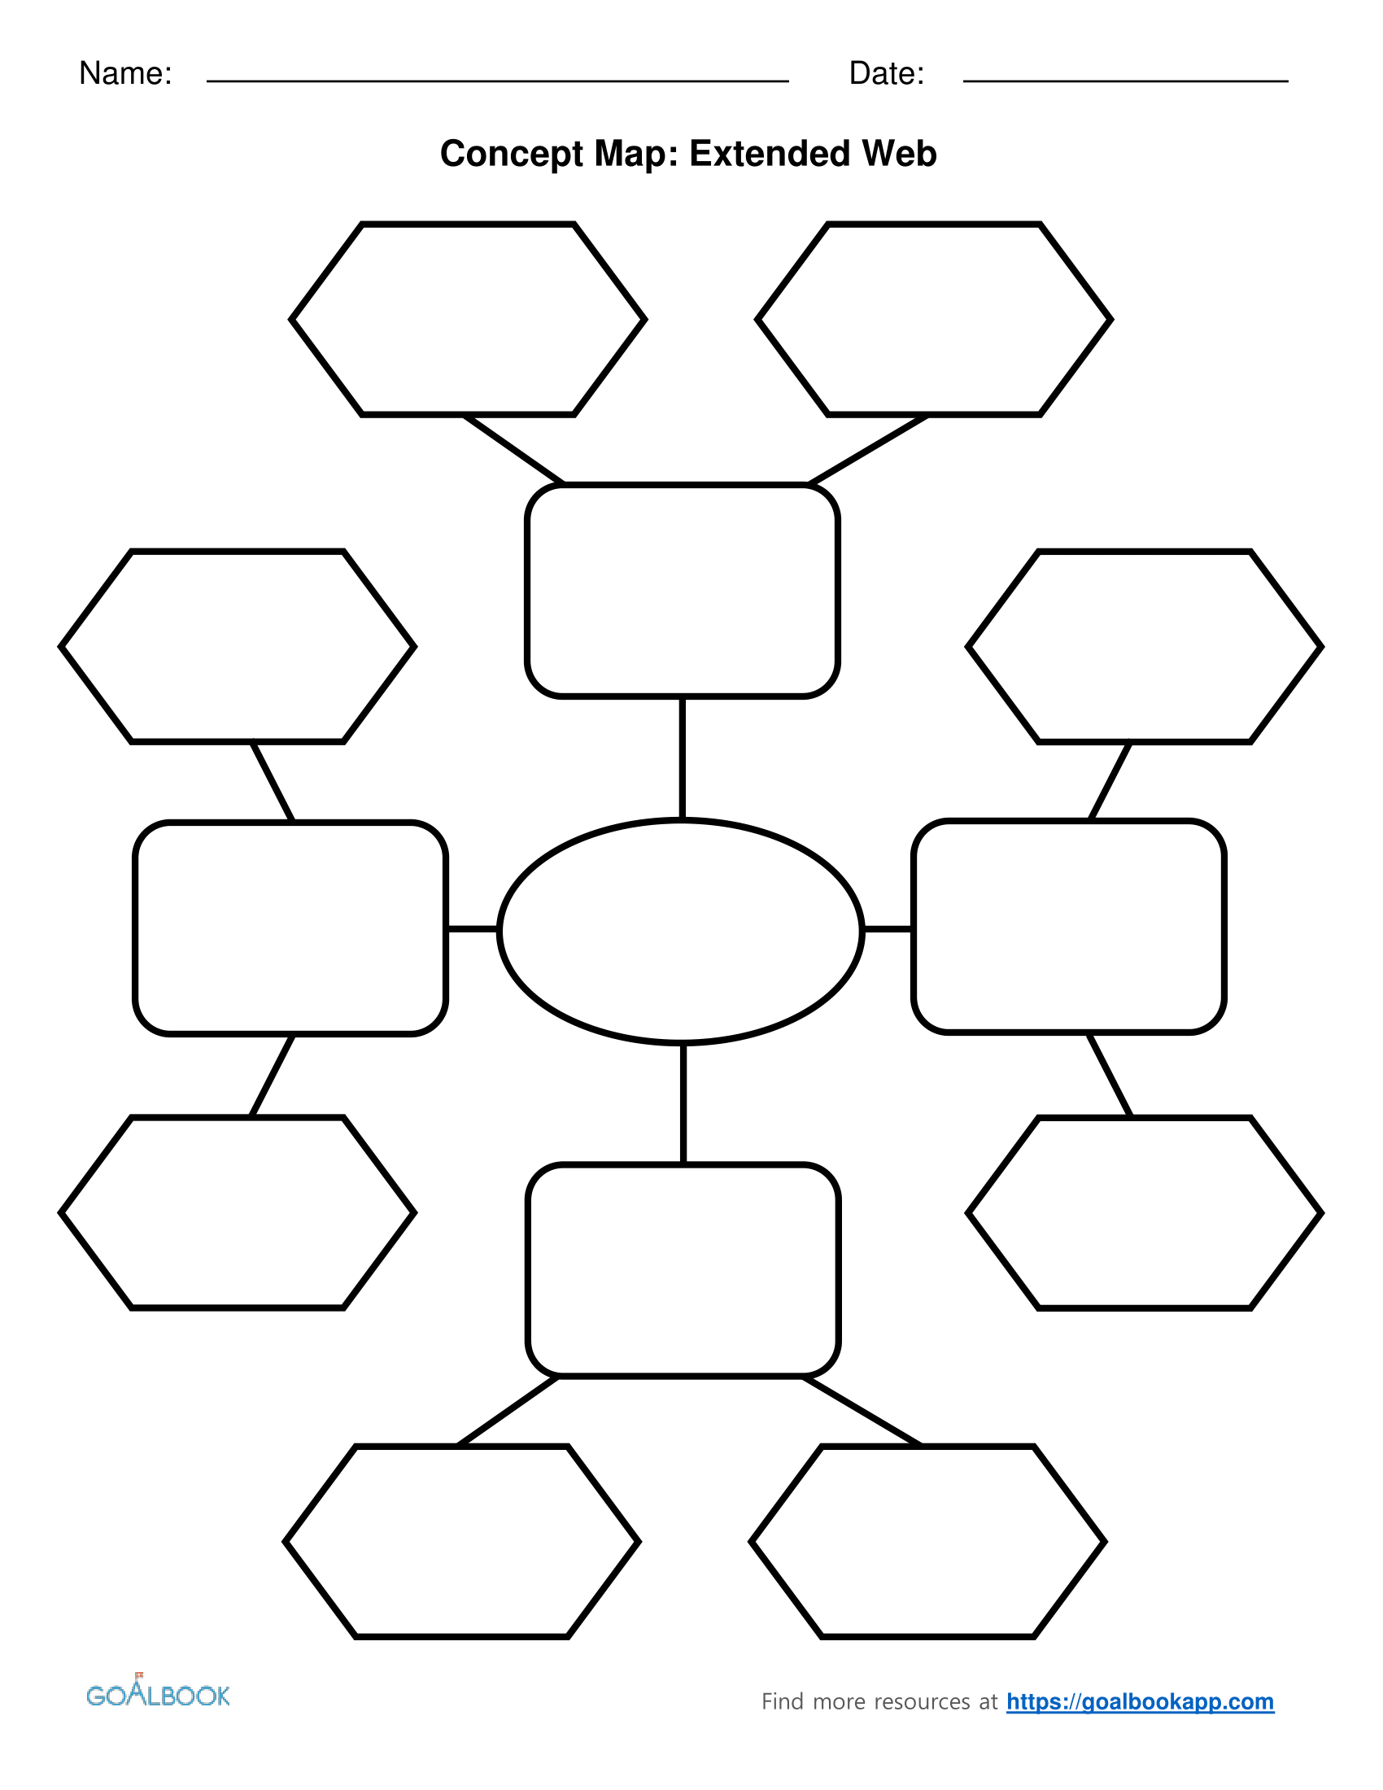

What do I want to improve?

What things could I do to improve?

What do I want to improve?

What do I want to improve?

What things could I do to improve?

What things could I do to improve?

What things could I do to improve?

What do I want to improve?

Type of Relationship

Type of Relationship

Type of Relationship

Relationships in _______________’s life

Type of Relationship