Quick Write #10: A Poppy Is to Remember
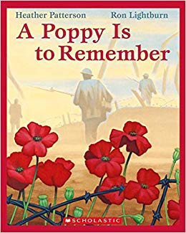
You will write for 6 minutes.
Guiding Prompts:
- How does the story make you feel?
- Why is it important to wear a poppy in November?
- What other things can we do to remember the soldiers, nurses, doctors, ambulance drivers, pilots, families struggling at home, and the political leaders involved in WWI and WWII?
- Can you make any personal connections to this book? What are they?
- Write your own story about WWI or WWII and include poppies in your version.

