Quick Write: Your Favourite Movie
Guiding Prompts:

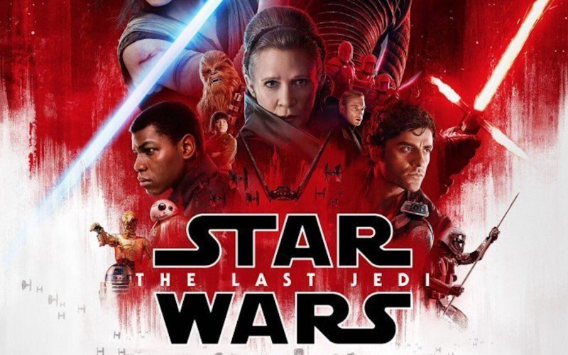
- What is your favourite movie series/trilogy/saga? What makes them so interesting?

- If you have no favourite movie series, what is your favourite movie and why is it your favourite?

- What is your favourite movie series and who is your favourite character? Why do you admire them?

- Make a list of movies that you would recommend to other people and write a one or two sentence reason for your recommendation.

